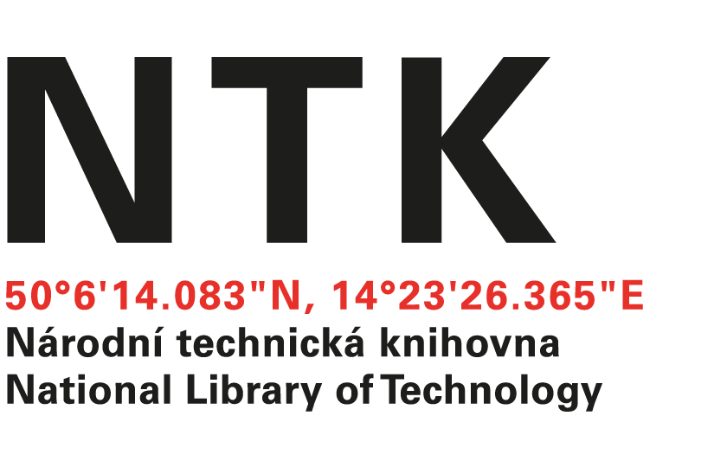
Licence Agreement

Parties to the agreement:

National Library of Technology, 160 80 Praha 6, Dejvice, Technická 6/2710,
Established by the Czech Ministry of Education, Youth and Sports
IČ: 6138 7142
VAT: CZ61387142
Bank account details: ČNB Praha, account no. 8032-031/0710
Represented by Martin Svoboda, Director
(hereafter referred to as “licensee”)

and

Name
With permanent residence at [CITY] [COUNTRY]
Born on [DD][MM][YYYY]
(hereinafter referred to as “licensor”)
(jointly referred to as “parties to the agreement”)

within the meaning of Section 46 and subsequent provisions of Act No. 121/2000 Coll., Copyright Act of the Czech Republic, as amended (hereinafter referred to as “CA”) enter into the following Licence Agreement:

I.
Preamble
I.1 Licensor is the author of a paper and presentation for the 16th IFLA ILDS Conference "Beyond the Paywall: Resource Sharing in a Disruptive Ecosystem." By this license agreement he/she grants the licensee non-exclusive rights to make use of the paper as stated in Article III of this agreement.

II.
Subject Matter
II.1 The subject matter of this agreement is to license the work consisting of a paper and presentation entitled “xxx” within the scope specified in Article III of this agreement.

III.
Scope of the License
III.1 The licensor grants the non-exclusive right to the licensee to make his/her work public within the meaning of Section 10 of the CA, to reproduce the work within the meaning of Section 13 of CA, to distribute the work within the meaning of Section 14 of CA, to communicate the work to the public within the meaning of Section 18 of CA, as well as to any other kind of use necessary to publish the work in the Czech National Repository of Grey Literature (NUSL) conference proceedings (ISSN 1803-6015) and archiving of the work in the NTK Institutional Digital Repository at: https://www.techlib.cz/en/2975-ntk-repository. The licensor grants a non-exclusive right to the licensee to any kind of use necessary to publish the reproducing of the work in the National Repository of Grey Literature at: https://nusl.techlib.cz/en and in other databases from which NUSL content is harvested (updated list of these databases is available at: https://nusl.techlib.cz/en/nrgl/nrgl-and-international-cooperation).
III.2 The license is granted as non-exclusive, unlimited by territory and time.
III.3 The licensee is entitled to enter into sub-license agreement within the meaning of Sections 48 and 57 of the CA.
III.4 The licensor is entitled to merge the work with other works, to include the work into a collection within the meaning of Section 51 of the CA, or to entitle another person to use the work in the manner specified by this provision.
III.5 The licensee is not obliged to utilize the license within the meaning of Section 46 Paragraph 3 of the CA.

IV.
Video presentation
IV.1 The licensor grants permission to webcast in real-time and publish a video presentation of acquired contributions recorded on 9-11 October 2019 in Prague during the 16th IFLA ILDS Conference "Beyond the Paywall: Resource Sharing in a Disruptive Ecosystem."
IV.2 The licensor agrees with publishing of video presentation in the NTK Institutional Digital Repository at: https://www.techlib.cz/en/2975-ntk-repository and distribute similarly as stated in Article III of this agreement.

V.
Remuneration
V.1 The license is provided free of charge.

VI.
Final Provisions
VI.1 The licensee hands over to the acquirer also the metadata necessary for publication of the work in the database. These metadata may contain also personal data. Further information about personal data processing is provided on NTK´s IDR web page. (The GDPR-compliance statement is accessible directly at: https://www.techlib.cz/download/86475/personal-data-processing-idr.pdf.)
VI.2 All annexes constitute an integral part of the agreement.
VI.3 The agreement may be amended only by the amendments in writing which will be expressly labelled as amendments, numbered in ascending manner, and will become an integral part of the agreement.
VI.4 Two copies of the agreement are signed simultaneously and both are considered to be original.
VI.5 The agreement enters into force in the moment it is signed by the parties to the agreement.
VI.6 The rights and obligations arising from the agreement transfer to the legal successors of the parties to the agreement.
VI.7 In case any of the provisions of the agreement are made void, the parties to the agreement are obliged to cooperate, in order to replace it with a new provision, within 14 days after the discovery of any voidance.

Date: Date:

Licensee Licensor
________________________________________________
Martin Svoboda Name
Director

